# Name: “sigma expansion pack” (Absolute Tuff)

1. ~~Sigma Block:~~ 
   1. ~~Obsidian – karll4204~~
   2. ~~Sigma Armour – nikodev~~
   3. ~~Sigma Tools - nikodev~~
   4. Tuff Edit every tick we mine it. – The World Machine
   5. ~~sigma block should give 3000 diamonds every time you say sigma in chat – friedchickeneater400~~
2. Mango
   1. Grows on Mango Trees - Cuddles
   2. Heals 6 or 7 Hearts – karll4204 / Cuddles
   3. Fire Resistance for 67 seconds – friedchickeneater400
   4. every time you eat a mango a tuff mango phonk edit shows up – friedchickeneater400
   5. dark mango theory – Cuddles
3. Kendrick Lamarr (so tuff)
   1. add kendrick lamar npc which drops mangos and mustard – friedchickeneater400
4. Tools
   1. ~~Change every tool to TRIPLE T BABY!!!!!!!!!! (different colors)~~
5. Items
   1. 64 to 67 max stacks whatever dude – Mars (Ralph)
      1. ***only tuff related items can be stacked to 67 - nikodev***
6. Tuff
   1. tuff nuggets from tuff when brush is used – nikodev
   2. tuff items aswell - nikodev
   3. add tuff nether -friedchickeneater400
7. Villagers
   1. ~~everytime you trade with a villager it will play the property meme in egypt audio – Vivian~~
8. Final Boss-Fight
   1. Undertale Flowey style “Your Best Nightmare” and “Finale” (Where you fight brainrot) – thefirey33
9. Whenever you craft something related to TUFF, phonk plays for a few seconds – The World Machine
10. Goku instead of the Wither – Lunar [ Cedric ]
11. Kevin MacLeod Songs – karll4204

metin, yazı tipi, ekran görüntüsü içeren bir resim

Yapay zeka tarafından oluşturulmuş içerik yanlış olabilir.

(Solar [Solar])

1. ADD A SCREEN OF PEOPLE PLAYING BLOX FRUITS WITH THEIR LIF EON THE LINE WITH A BUNCH OF MANGOES IN THEIOR MOUTH AFTER YOU DIE – Sleepy
2. when you craft **mangoes** and **mustard** it crafts mustard'ed mangoes which heal all hearts and give fire resistance 4 for 3 hours – friedchickeneater400
3. if you land a quick chain of sword hits it starts playing this song with cool edit effects - Solar [ Niko ]

maybe with "GO! GO! GO! GO!" text in the background n' stuff just like super motivating text

1. 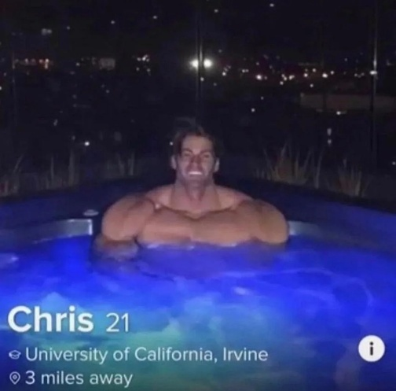Add Chris from Tinder (Boss, RLLY HARD) - friedchickeneater400
2. Add mustard. – friedchickeneater400
3. Add Herobrine – friedchickeneater400